**Mutahra Salman**

**21-11447**

**Software Quality Assurance CSSE 351 Section A**

**Assignment 2**

**Introduction**

In this assignment, we were given a task to run an automated test using selenium tool in any language and generate a result. Selenium is a very powerful tool which can automate quality assurance tests very easily and it has a vast variety of browsers and languages to choose from.

For this assignment, I did API testing of my FYP backend which was written in node js and FE in react. I used chromium web driver v103 with chrome version 103 as well, and implemented API testing of two business critical use cases :

1. Login
2. Edit Profile

**Step 1:** Installing Selenium:

* Selenium’s npm package was installed in the mern app as can be seen in my package.json file:

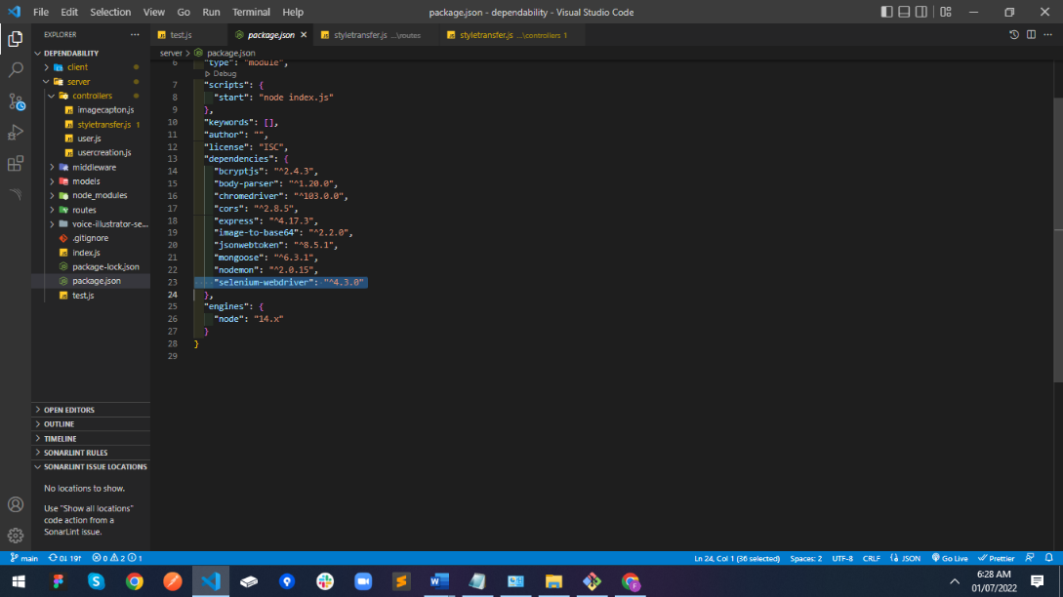

* Chrome’s webdriver was installed and its system’s PATH updated:

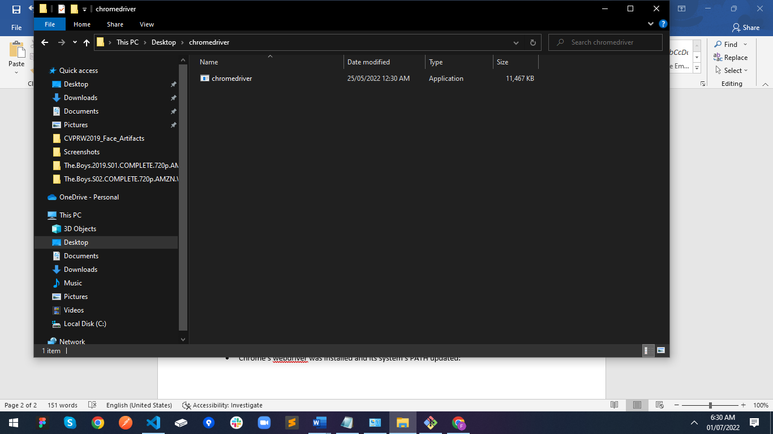

**Step 2:** Running the tests:

The URL for the FYP project under testing can be found at:

<https://voice-illustrator-main.vercel.app/>

One can go over it and see this page

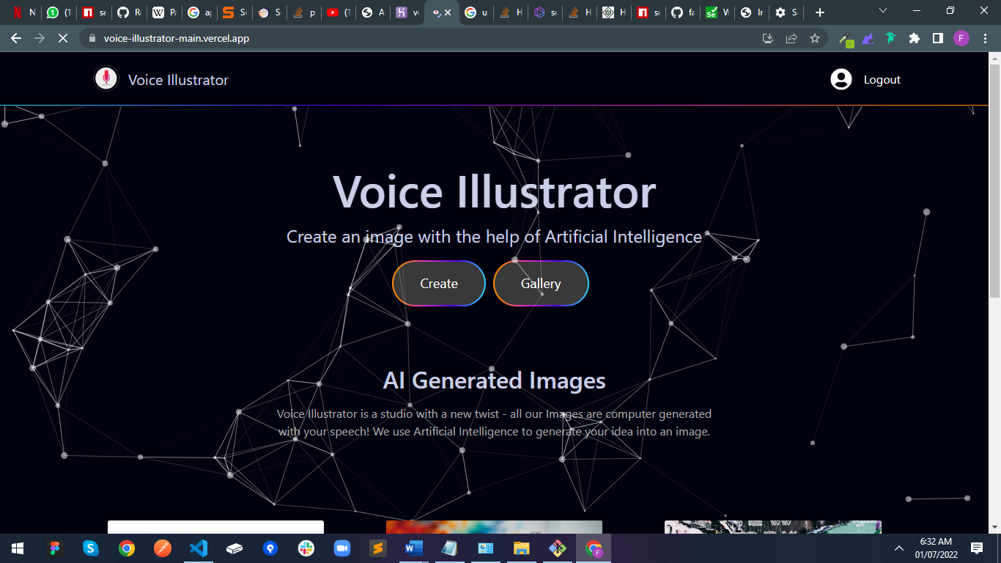

And the login pages and my profile pages under testing are as follows:

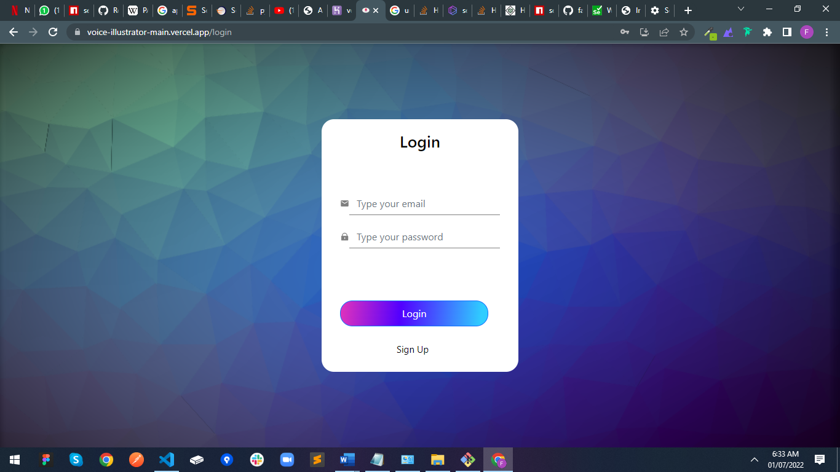

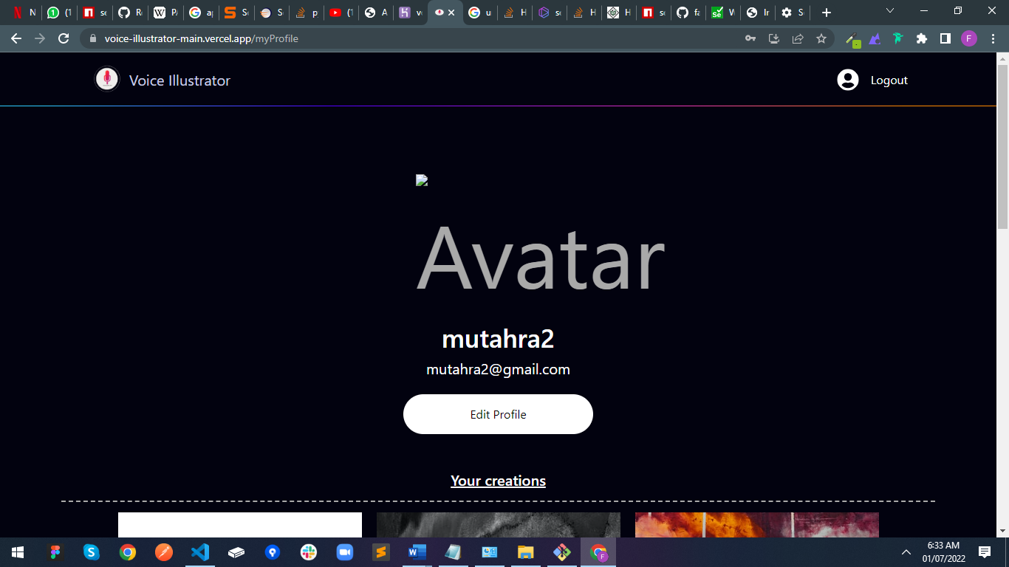

**Step 3:** Sign In Application

The main app was run and the login page opened with my credentials given. This was to test the Sign In API at localhost:5000/signIn which gets email and password. The script can be found in the test.js file in server sub-folder:

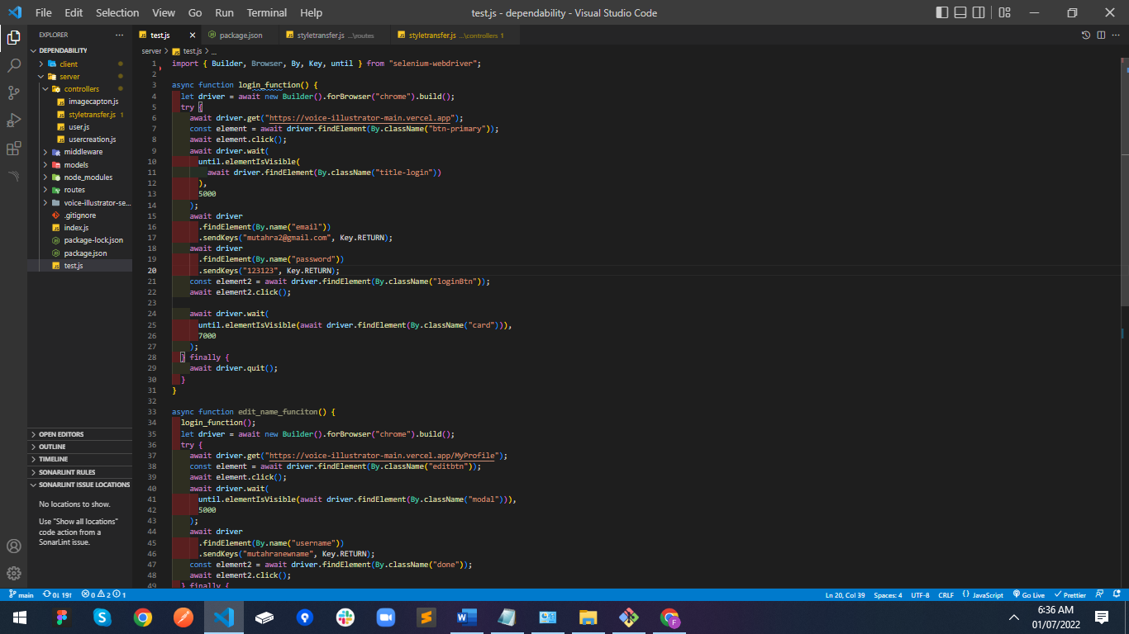

**Step 4:** Update Profile Application

The main app was run and the login page opened with my credentials given. This was to test the profiles API at localhost:5000/getMyProfile which gets my jwt token and return the details. The script can be found in the test.js file in server sub-folder:

